AIAC Assignment 2.3

Name: B Praneeth
HT No : 2303A52005
Batch 31

Question
Task 1:
Word Frequency from Text File
Scenario: You are analyzing log files for keyword frequency. Task: Use Gemini to generate Python code that reads a text file and counts word frequency, then explains the code
Promt:

Create a Python program that creates a text file, writes sample text into it, then reads the file and displays its contents.
Add clear comments in the code.

code screenshot
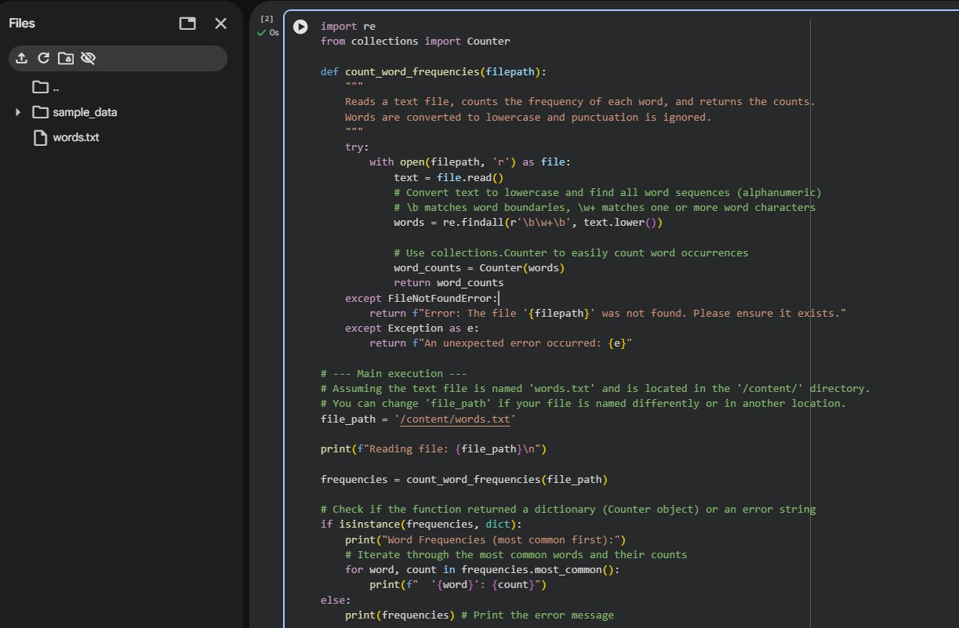
Output
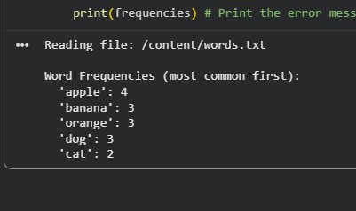

Explaination
This program reads a text file and splits the content into words. Each word is stored in a dictionary where the key is the word and the value is its count. If a word appears again, its count is increased. the program prints how many times each word appears in the file.
Question
Task 2:
File Operations Using Cursor AI
Scenario: You are automating basic file operations.
Task: Use Cursor AI to generate a program that:
Creates a text file
Writes sample text
Reads and displays the content
prompt
generate a python program, which creates a text file, write sample txt eg.fruits in that, read and display that content.
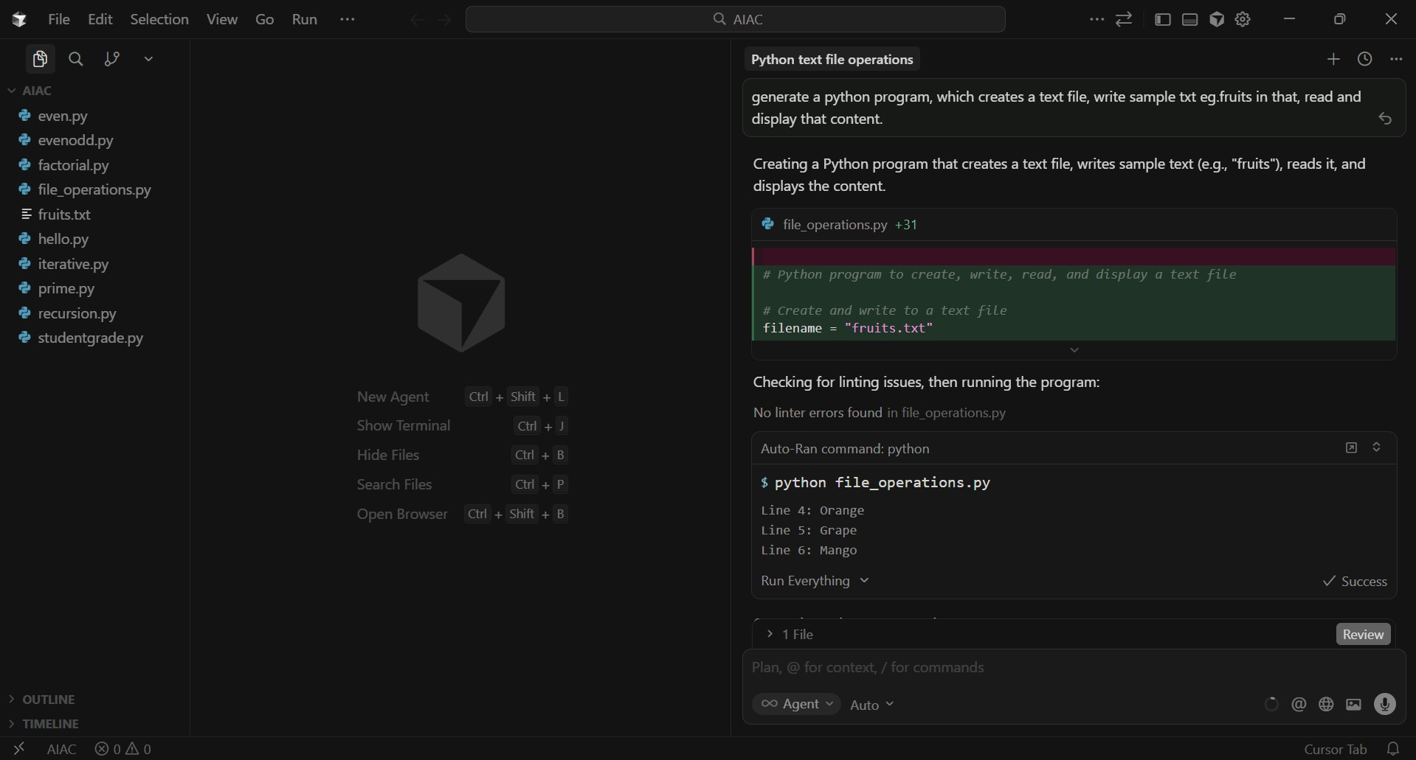

Code screenshot

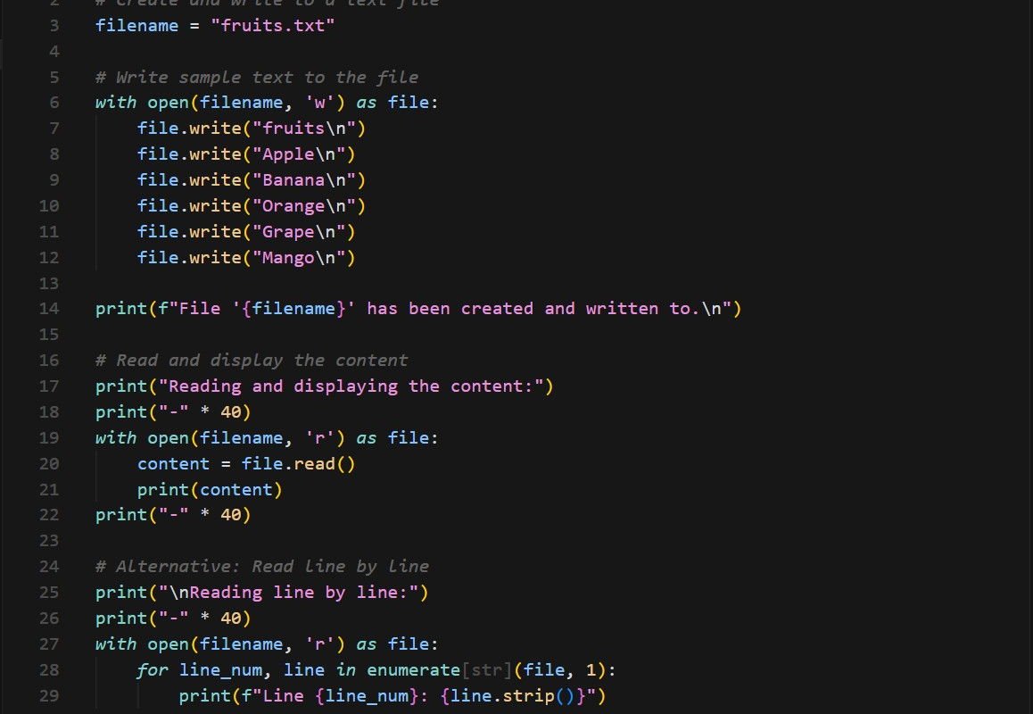

Output
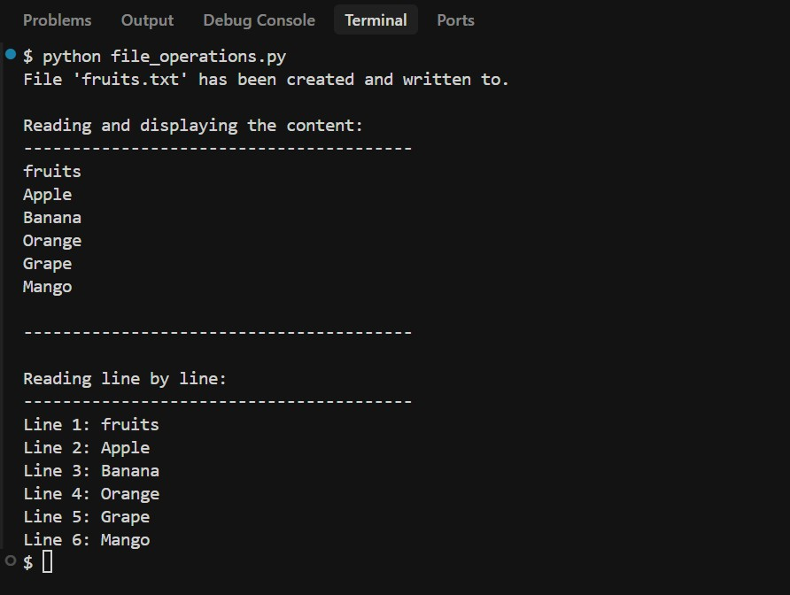
Explaination
This program demonstrates basic file handling in Python using Cursor.
First, a text file is created and sample text is written into it.
Then, the same file is opened in read mode and its contents are displayed on the screen.

Question
Task 3: CSV Data Analysis
Scenario: You are processing structured data from a CSV file. Task: Use Gemini in Colab to read a CSV file and calculate mean, min, and max.

Prompt
Generate Python code to read a CSV file and calculate the mean, minimum, and maximum values of a numeric column.

Code screenshot
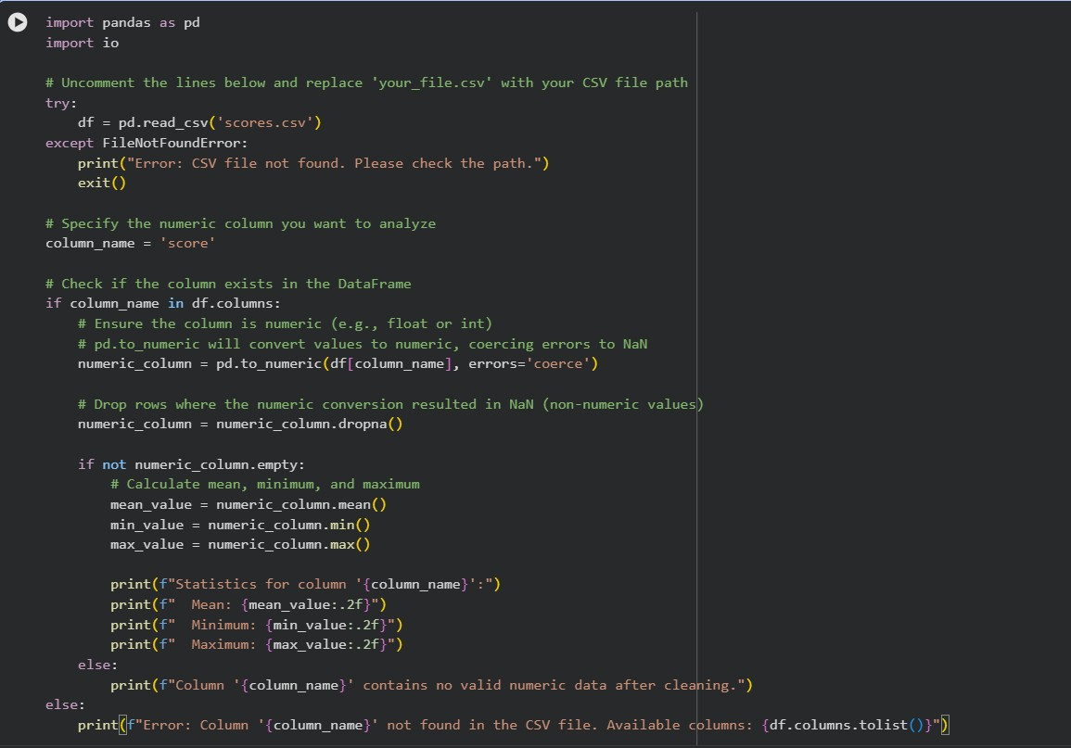
Output:
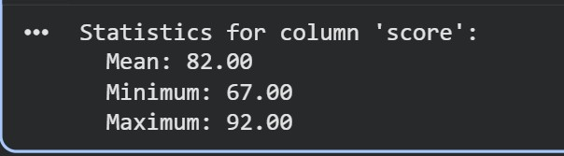
explaination
This program reads data from a CSV file using Python.
It extracts numerical values from a column and calculates the mean, min, and max.
CSV analysis is used in data processing and analytics applications.

Question
Task 4: Sorting Lists Manual vs Built-in
Scenario: You are reviewing algorithm choices for efficiency.
Task: Use Gemini to generate:
Bubble sort
Python’s built-in sort() Compare both implementations.

code screenshot
Manual Bubble Sort Code:
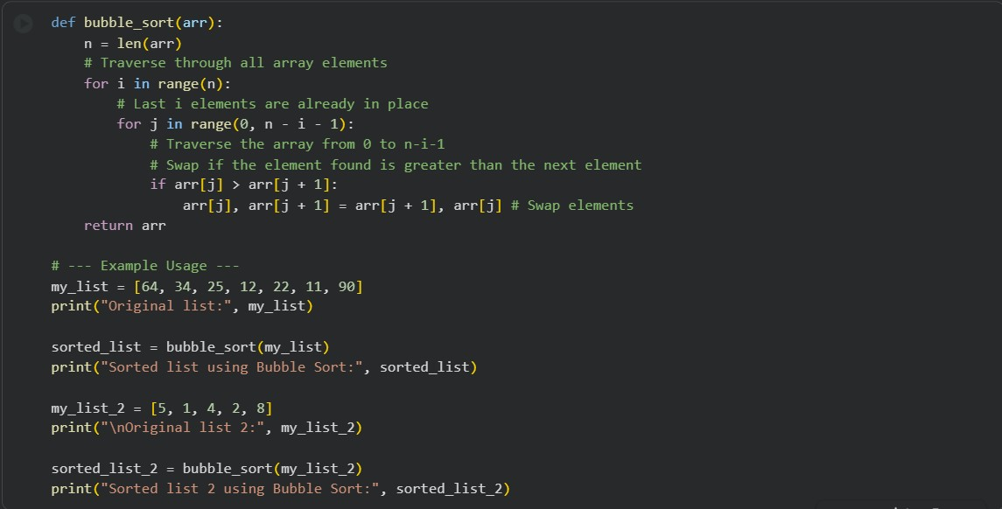
Sorting using sort() function:

output
Bubble sort:

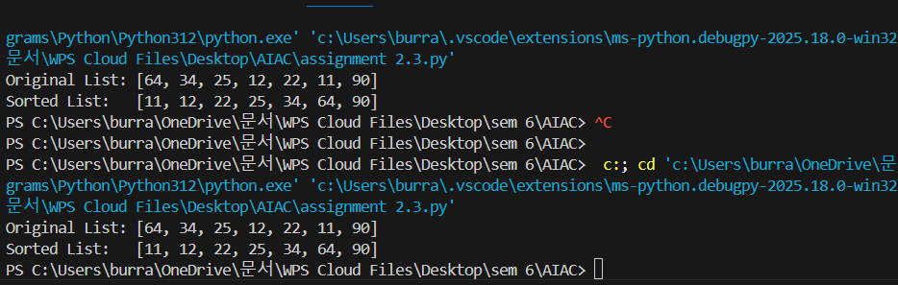

Sort Function:
explaination
Bubble sort is a simple sorting algorithm that repeatedly compares and swaps adjacent elements. It is easy to understand but inefficient for large data sets.
Python’s built-in sort function is shorter, optimized and much faster.

